長庚大學資訊工程學系一百零九學年度上學期計算機圖學課程小考2試題
上課班級: 三年甲班 授課老師: 林俊淵
受測範圍: Slides 1~6

- Please write an OpenGL program to draw the picture. (Total: 50 points)
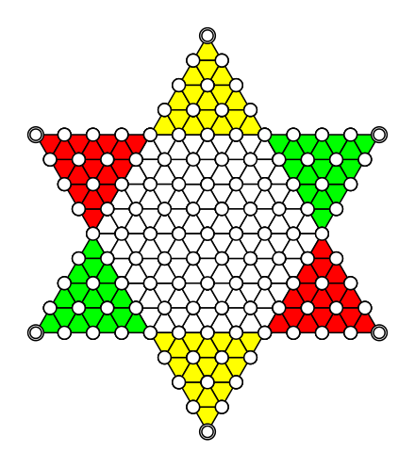  Figure 1 | - Create a windows with a size of 600x600.  - Draw the Chinese checkers as Figure 1.  - It has 2 triangles.  - Each triangle has 13 levels.  - Each point is a circle.

- Please write an OpenGL program to draw the picture. (Total: 50 points)
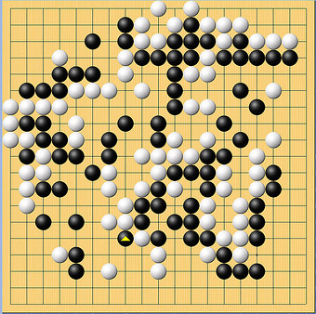  (example) | - Create a windows with a size of 600x600.  - Display a GO board with 18x18 boxes (19 lines x 19 lines). Each box with a size of 30x30.  - At first, please random generate a GO black at the intersection of lines, then generate a GO white, and then alternately. (with 150 GO black and 150 GO white)  - Each white/black with a size of 30x30.  - When a GO white is surrounded by GO black, or a GO black is surrounded by GO white, then change its color to red.

完成全部作答後, 需要繳交以下檔案:
- .c or .cpp 檔案. (請標名學號-1, 學號-2)
- .exe檔案. (Mac不用)(請標名學號-1, 學號-2)
- 跑出來的圖形( .jpg) (請標名學號-1, 學號-2))

請記得儲存檔案，請將全部檔案壓縮成【學號.rar/學號.zip】然後上傳到ftp上.

